**JFreeChart**

This document summarizes the steps involved in generating the bug reports and calculating the Backlog Management Index of open source projects using GitHub issue tracker. We have taken an open source projects – JFreeChart for the demonstration purposes.

Unlike some other open source projects, JFreeChart does not have a well-defined issue tracker like JIRA or Bugzilla, so this document will demonstrate how the bug reports can be generated using GitHub’s issue tracker which are summarized as follows.

1. Open the GitHub page for JFreeChart.

<https://github.com/jfree/jfreechart>

1. In the topmost section, we can see different options. Select *Issues.*

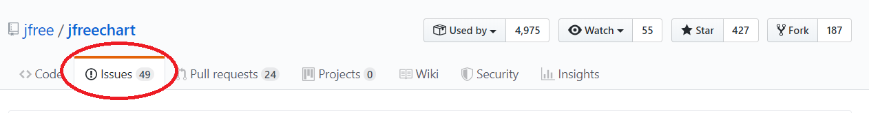

1. We can use different filters to extract different information from the tickets. For example,

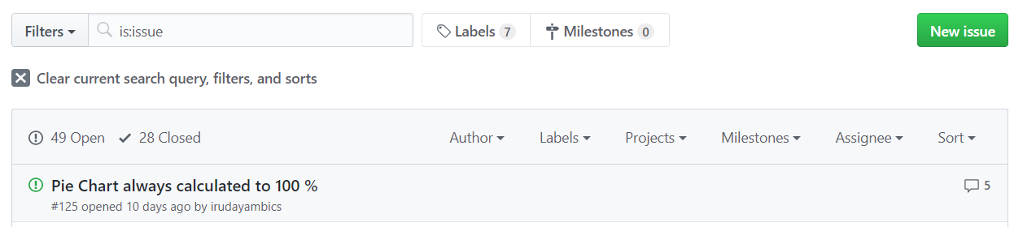

This default filter will give all the tickets that are issues.

1. For BMI, we will be requiring the number of issues created in a month and the number of issues resolved in a month. So the filters we will be using are:
   1. **is:issue created:2017-07-01..2017-07-31**

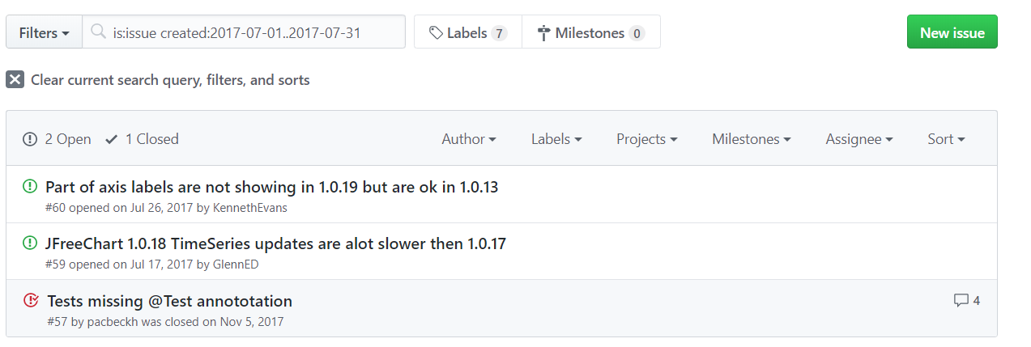

The above image shows that 3 issues were created in the month of July. Out of these 3 issues, 2 of them are still open and one was closed in November 5, 2017. So the third issues will be contributing to the denominator for July and the numerator for November.

* 1. **is:issue closed:2017-07-01..2017-07-31**

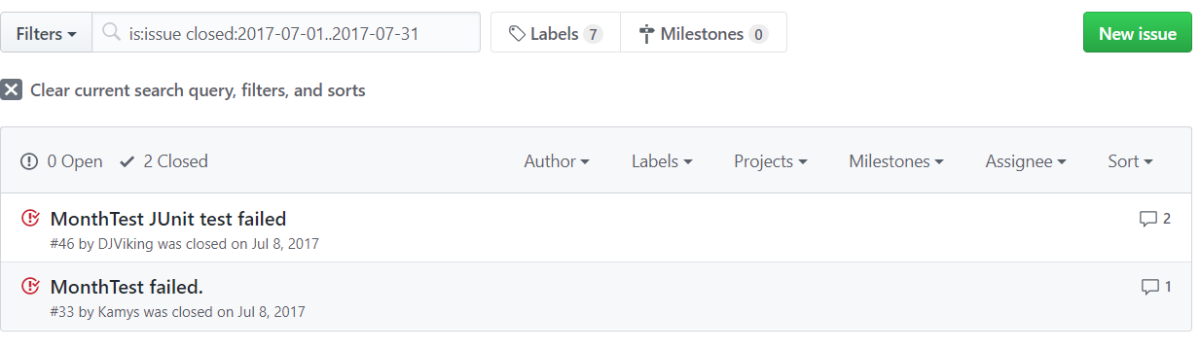

This shows that 2 issues were closed in the month of July. It does not matter when these issues were created while taking the denominator for the month of July.

So, from these metrics, we can calculate the BMI for the month of July 2017 as follows:

**BMI = No. of problems closed during the month of June X 100%**

**No. of problems arrived in the month of June**

**= 2 X 100%**

**3**

**= 66.67%**

Since, this value is less than 100%, it shows that the issue backlog has increased.

1. In the similar fashion, we can calculate the BMI for each month.

|  |  |  |  |
| --- | --- | --- | --- |
| **JFreeChart** | | | |
| **Month** | **Issues Created** | **Issues Closed** | **BMI(%)** |
| **Jun-18** | 2 | 0 | 0.00 |
| **Jul-18** | 3 | 1 | 33.33 |
| **Aug-18** | 0 | 0 | 0.00 |
| **Sep-18** | 3 | 0 | 0.00 |
| **Oct-18** | 2 | 0 | 0.00 |
| **Nov-18** | 6 | 2 | 33.33 |
| **Dec-18** | 2 | 1 | 50.00 |
| **Jan-19** | 4 | 0 | 0.00 |
| **Feb-19** | 0 | 0 | 0.00 |
| **Mar-19** | 0 | 0 | 0.00 |
| **Apr-19** | 1 | 0 | 0.00 |
| **May-19** | 1 | 0 | 0.00 |

Here, we can see that most of the months have a BMI of zero. This indicates that this is not an active project with dedicated developers. Usually in commercial software, the BMI will not be zero. Also, if the denominator is zero, the BMI will be infinity according to the formula. Since a software having infinite BMI does not make any sense, the BMI is taking as zero for these cases as well.